**SEASONAL AND TREND DECOMPOSITION USING LOESS**

ABSTRACT:

Most time series forecasting processes start with first decomposing the data into the three components trend, seasonality and error. Only after the decomposition is done, does the actual forecasting process starts. STL is a unique decomposition technique which uses locally weighted regression for the decomposition. Once the decomposition is done, the data set is passed on to any one of the several forecasting

techniques that are commonly used- “ETS”,” Arima”,” Naive” and “rwdrift”.

1. THE DECOMPOSITION TECHNIQUE:

The STL decomposition process is demonstrated here using a flow chart with a table for all the necessary notations.

|  |  |
| --- | --- |
| Term/Notation | Explanation |
| Y | Original value at some point of time |
| N | The number of points in the dataset |
| $$T_{n}^{(0)}$$ | The trend value before the 1st pass, often taken to be 0 |
| Cycle Subseries | For a monthly dataset, 1st cycle subseries consists of all January values,2nd consists of all February values and so on |
| Loess | Locally Weighted regression, a smoothing process |
| $$C_{n}^{(1)}$$ | Collection of all smoothed values |
| $$L_{n}^{(1)}$$ | Smoothed value after passing $C_{v}^{(1)}$ through  moving average filter |
| $$S_{n}^{(1)}$$ | Seasonal component calculated in the 1st pass |

STL

Decomposition

2.)Locally Weighted Regression (LOWESS):

Seasonal Component of every point in the 1st pass through the inner loop calculated by

$${S^{(1)}}_{v}={C^{(1)}}_{v}-{L^{(1)}}_{v}$$

Trend smoothing done by running LOWESS on

$${Y^{(1)}}_{v}{{-S}^{(1)}}_{v}$$

More inner passes?

Collection of all smoothed values ${{ C}^{(1)}}_{v}$, passed through a filter of moving average to get

.

Cycle subseries smoothing by LOWESS

Inner Loop

Final Decomposition

Robustness weights for each time point

Assigned

Outer Loop

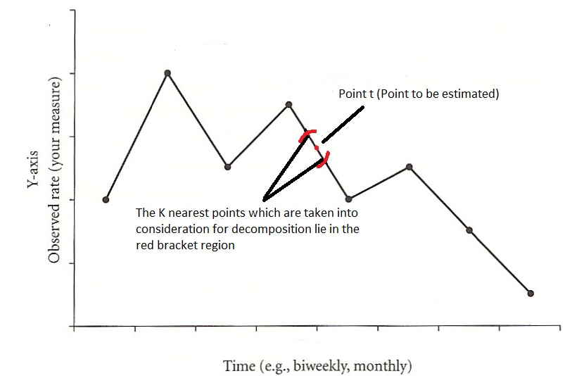

Figure 1

To understand the STL decomposition technique fully, we need to understand LOWESS. If the point t is to be estimated (or decomposed into error, trend and seasonality), a locally weighted regression approach would take into consideration the nearest k points for the purpose. Here, the points nearer to the point t are given more weightage and the points far away are given less weightage when estimating the point t.

3)Step by Step decomposition:

The STL decomposition takes place through the functioning of two loops, the inner and the outer loop. The stepwise process is as follows:

The data first enters the outer loop. In the initial run, every data point is given equal weight and the data is sent to the inner loop. Once in the inner loop, it goes through cycle subseries

4)Cycle Subseries Smoothing:

To understand cycle subseries smoothing, let us take the help of an example. Suppose we have the monthly sales volume for 7 years of a product starting from January 2010. Now for a cycle subseries smoothing of this data set we would have to plot all the January sales volumes through the period 2010-2016 together, all the February volumes together and so on. So in the plot, the x axis would have only the 12 months (The image below contains only 6 months for easier representation). Once we have the data in the said format, we estimate each point in the data set using LOWESS. Suppose we are to 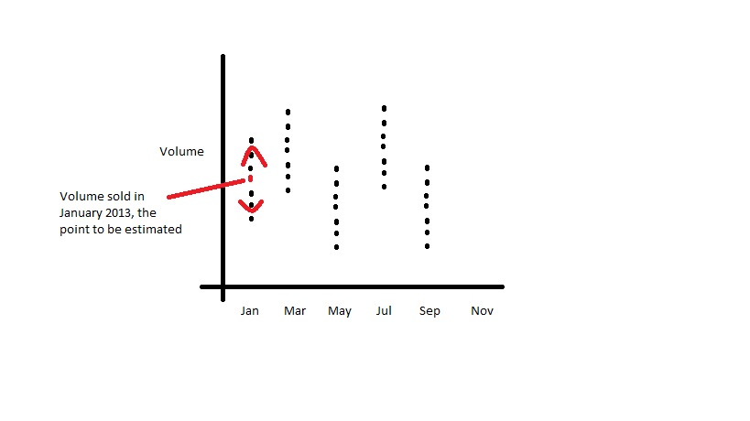estimate January 2013, the only point in red in the diagram, we take into account only the nearest k January volumes for the purpose. This is what is known as Cycle subseries smoothing.

Figure 2

Cycle subseries smoothing is the initial voice removing technique of the model. Once done, all the smoothed values are taken together and passed through a moving average filter, the second voice removing process of the model. When we subtract the output we get from the moving average filter from the cycle subseries smoothing result, we get the seasonal component of the data set. Subtracting the seasonal component from the original data gives us the deseasonalized. This deseasonalized part of the data is sent through another round of LOWESS smoothing which gives us the trend component of the data set. STL gives the option of repeating this process as many times as desired. So theoretically the number of inner and outer loop iterations are controllable. But the STL package in R does not allow us the flexibility of controlling the number of inner and outer loop iterations. Once the inner loop iterations end, the data is passed on to the outer loop where each data point is reassigned weights which are used when the next set of inner loop iterations begin.

5) Weight function for LOESS in STL:

w (x)=(1-ӏxӏ^3)^3 ,x being the distance of a given data point from the point on the curve being fitted scaled to lie in the range of 0 to 1.

6) Carrying out Forecasting using STL in R:

Initially the “Forecast” package is called from the library. Once done, either of the two processes can be used to get the stl forecast results, the first one being the use of the simultaneous use of the two functions stlm and forecast.stl:

The function “stlm” deseasonalizes the times series data set and passes on the deseasonalized values which are then used to calculate future deseasonalized values by the forecast.stl function. In the end, the seasonal values of the corresponding season of the previous period are added to the deseasonalized forecasts to finally give us the forecasted values. This is the first process of forecasting using stl in R.

The second way of forecasting with stl is to use the function stlf:

The “stlf” command does is it does this entire procedure at one go. So it is recommended to use this function.

7) Parameters to be tweaked in R:

There are several parameters which are to be fixed so as to get the forecasts in the stlf function. The ones which deserve special mention are: s.window, t.window.

a) s. window: A metric to control the smoothness of the seasonality. Higher the number, smoother the trend. Having a higher S. Window value is recommended.

b) t. window: A metric to control the smoothness of the trend.

A higher t.window is recommended. The s.window should be 12 for monthly data, 4 for seasonal data and so on.

Another important parameter which can be tweaked in R when forecasting using STL decomposition is ETS.

c) ETS: Short for Exponential Smoothing State Space Model. This model is the default forecasting technique which is used by R.

Either of the error or trend components of the decomposed data set can be set to additive (A), multiplicative (M) or Z, where Z is either M or A, after which we get the deseasonalized forecasted values. To this is added the seasonal component of the corresponding season of the previous period to get the final estimates. The default ETS model which is used by R is ANN. The seasonal component is always kept Null (N) because the ETS forecast is done on deseasonalized values. Now if there is no visible trend and the same seasonality pattern repeats itself year after year, we can opt for the default AAN configuration but when we come across an increasing/decreasing trend and a change in seasonality pattern, we should check for the MMN, MAN configurations as well.

Some of the other forecasting techniques which are used are Arima, Naïve and rwdrift. However, ETS and Arima are the ones which are generally found to be the better forecasting techniques when using the STL decomposition technique.

The actual forecasting process can be explained thus through the following flowchart:

STL Decomposition

Deseasonalized values computed

Deseasonalized forecasts

Calculated by either of ETS, ARIMA, Naïve or rwdrift

*Final Forecasts*

(Computed by adding the seasonal components of the corresponding season of the previous period)

Reference Reading : Cleveland, Robert B., William S. Cleveland, and Irma Terpenning. "STL: A seasonal-trend decomposition procedure based on loess." *Journal of Official Statistics* 6.1 (1990): 3